Lesson 7:

**TYPE CHECKING**

**DATATYPE CONVERSION:**

**OPERATORS**

1. **Arithmetic Operator**

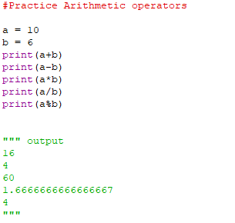

**2. Assignment Operator**



